Pendleton High School-Spring 2021
Hybrid AM/PM Bell Schedule and Gold & Green Calendar

GOLD DAY AM GREEN DAY AM
8:30 - 9:10 PERIOD 1 8:30 - 9:10 PERIOD 5
9:13 - 9:53 PERIOD 2 9:13 - 9:53 PERIOD 6
9:56 - 10:36 PERIOD 3 9:56 - 10:36 PERIOD 7
10:39 - 11:20 PERIOD 4 10:39 - 11:20 ADVISORY

GOLD DAY PM GREEN DAY PM
12:30 - 1:10 PERIOD 1 12:30 - 1:10 PERIOD 5
1:13 - 1:53 PERIOD 2 1:13 - 1:53 PERIOD 6
1:56 - 2:36 PERIOD 3 1:56 - 2:36 PERIOD 7
2:39 - 3:20 PERIOD 4 2:39 - 3:20 ADVISORY
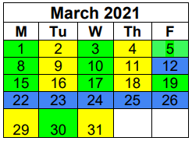
March 29th First Day of Hybrid Learning

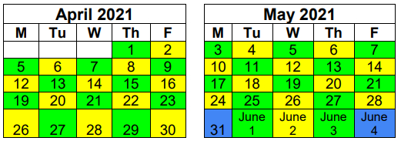
May 31st Memorial Day-No School
June 3rd Last Day of School

